

**SUBJECT: WEB SYSTEMS**

**TEAM: 404 NOT FOUND**

**MEMBERS:**

* **JOHN ELMER BLANQUISCO BOBIER JR.**
* **ROD B. RAÑOLA**
* **CHARLS EMIL C. BARQUIN**
* **CHRISTIAN JERIC NON**
* **Vincent Macauyam**

1. **DISPLAY ALL ITEMS:**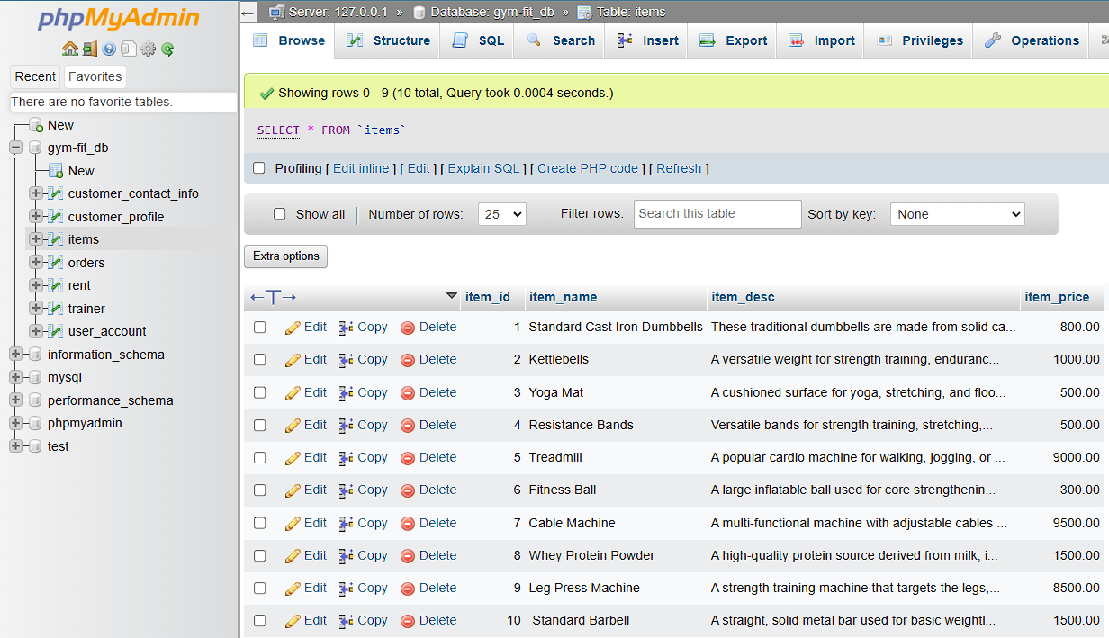



**In this step we inserted the name of the items, the item prices, and their own descriptions. After that we displayed the information for the item table.**

1. **DISPLAY ALL USERS**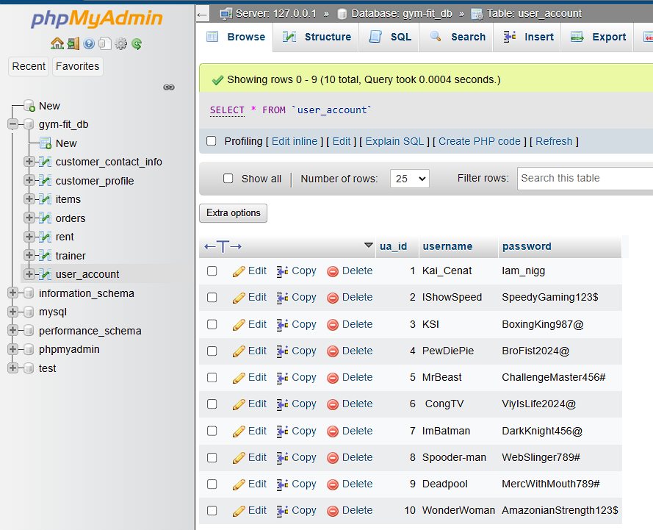



**We then created a new table for the users containing user-names and passwords. We then displayed the data for the user table.**

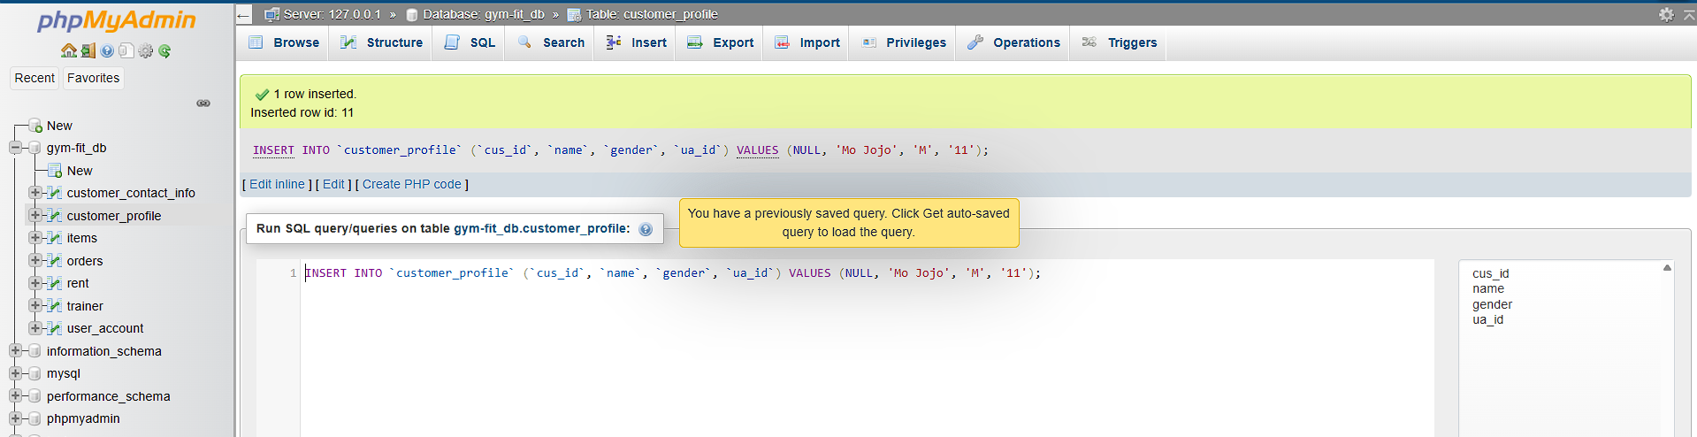

**We add some records to the Customer_profile table, having ensured that the ua_id should be in the users_account table. That was done for the purpose of verifying that there is no mismatch between customer profiles and user accounts in order to provide better control in terms of interaction with customers' data and acting upon it.**

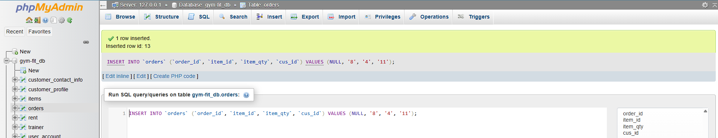

**We inserted orders in the Orders table, with the item_id you insert matching those listed within the item_ids and the cus_id already in the customer_profile table. This holds data integrity and relationships between orders, items, and customers are accurate. By enforcing these kinds of constraints, we can make the process more efficient about order processing and overall reliability of the database.**

1. **USING WHERE CLAUSE:**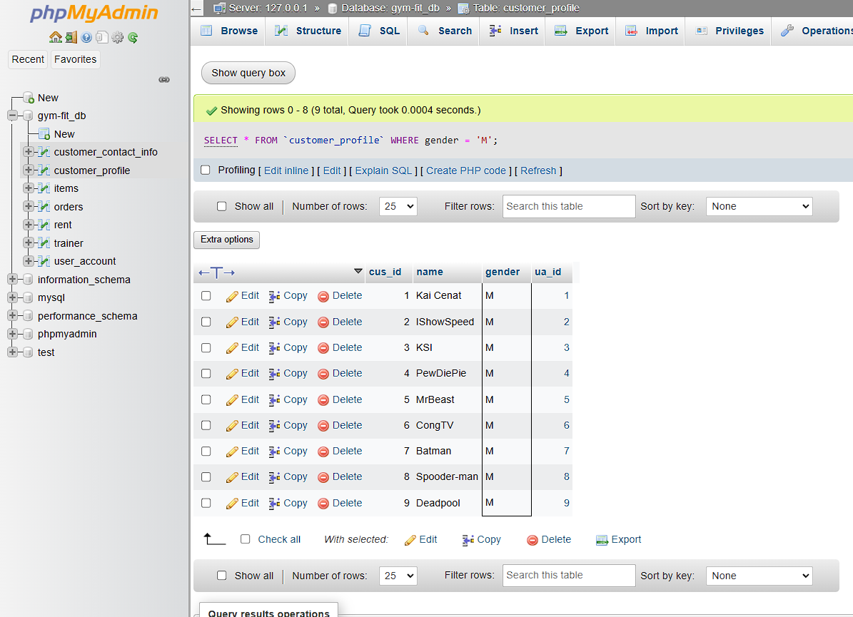

**This query would list all the customers in the customer profile table who are males or identified by an "M" in the gender category. You would find this helpful to know about your demographics of customer and would allow targeted marketing strategies to really have more resonance with the male audience.**

1. **DISPLAYING ALL ORDERS OF CUSTOMER ID 1 OR CUS_ID 1:**

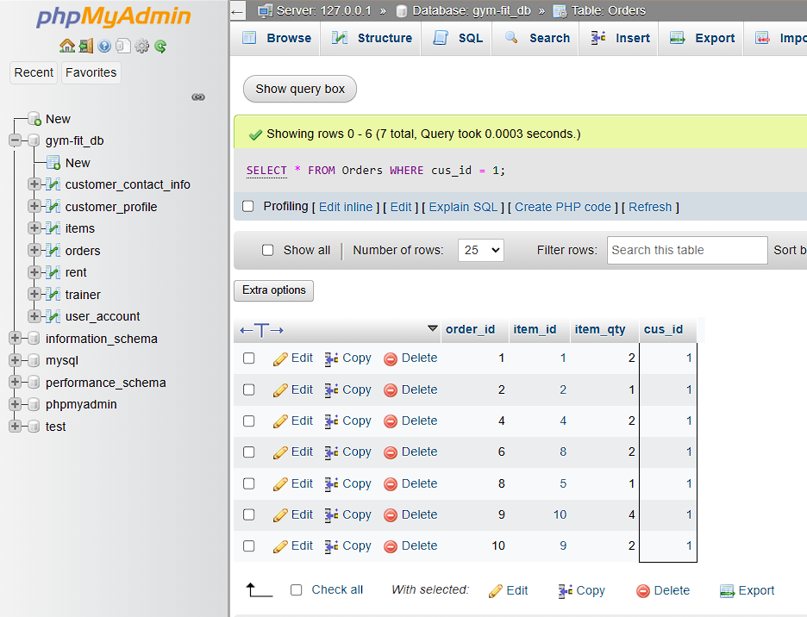

1. **DISPLAY SALES:**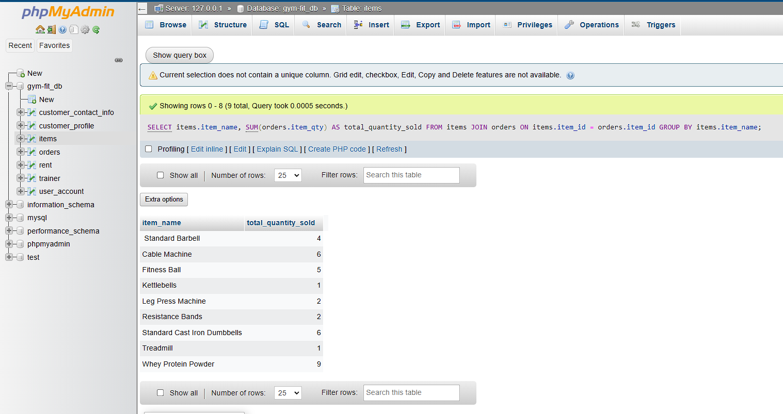



**We presented the total quantity sold for each product while making sure to only send descriptive columns and total quantity sold and nothing else in output. It's one way we can easily present our information in a clear and usable manner. Putting emphasis on the quantities, we can be better assured of which products are doing well. In the end, it helps us have well-informed decisions about our inventory and sales strategies.**

1. **DISPLAYING ITEMS HAVING MORE THAT 0 SALES**
2. **DISPLAY SALES:**

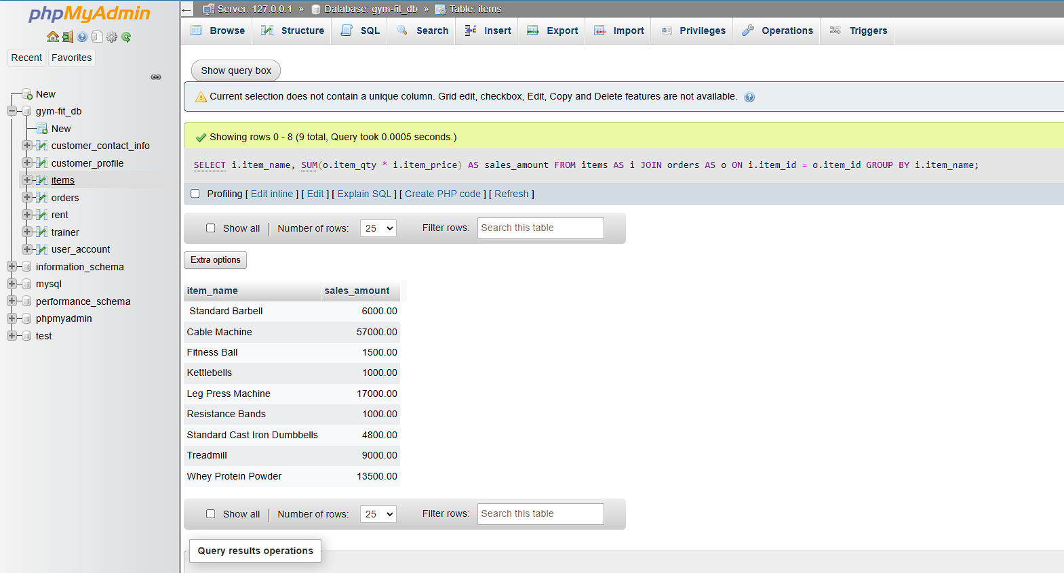

**We printed the sales per item. In that sheet, we only needed to print the item name and the sales amount. That way, we got to see clearly how every product is doing on a revenue basis. Being able to narrow it down to just those two columns helped us limit the information so we could analyze better. Meanwhile, we were able to quickly pin down which were our best-selling items. And overall, this exercise really gave us a good insight into the trends of sales, as it enabled us to strategize for future inventory. So I am just pleased how it all came out.**

1. **DISPLAYING THE TOTAL SALES PER DAY**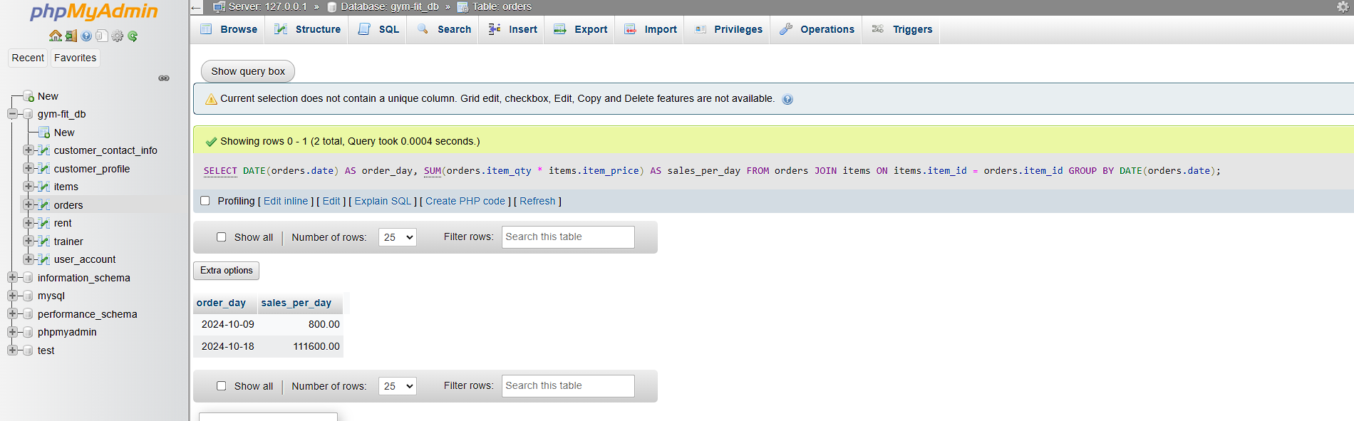
2. **DISPLAYING THE TOTAL SALES AND QUANTITY PER ITEM AND DAY**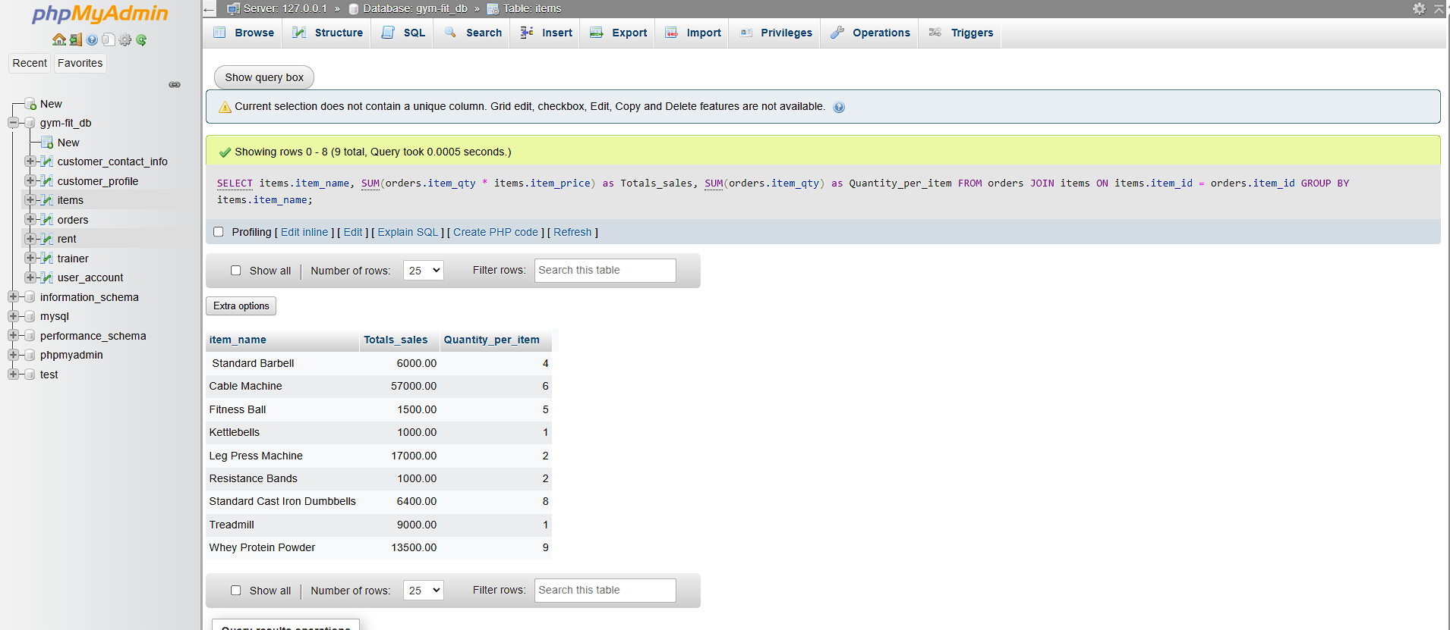



1. **DISPLAYING THE TOTAL SALES TOTAL QUANTITY SOLD PER ITEM AND DAY**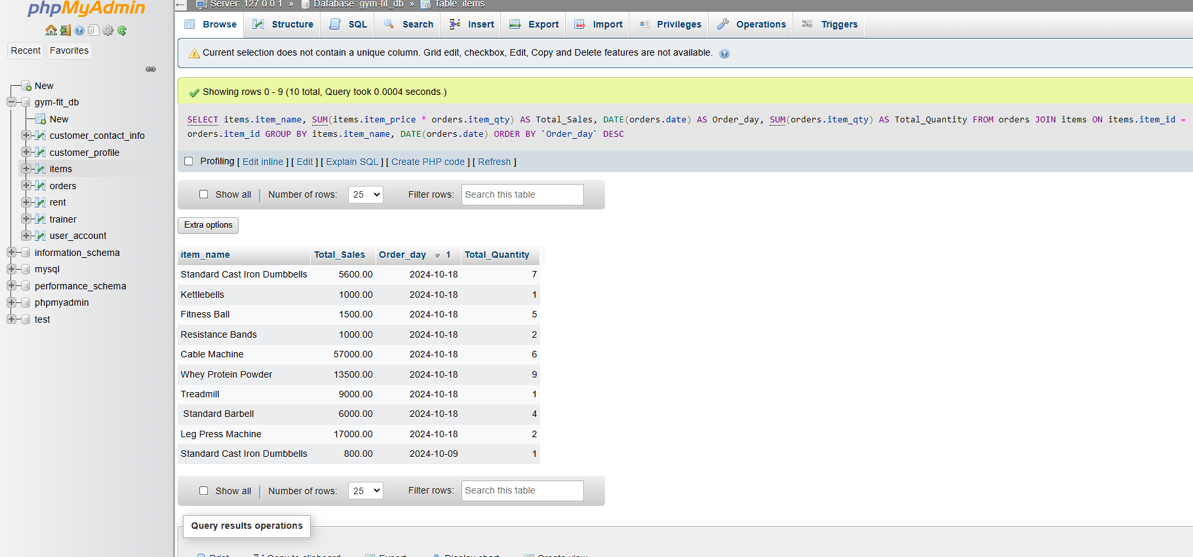



1. **DISPLAYING THE TOTAL SALES AND TOTAL QUANTITY SOLD PER FULLNAME** 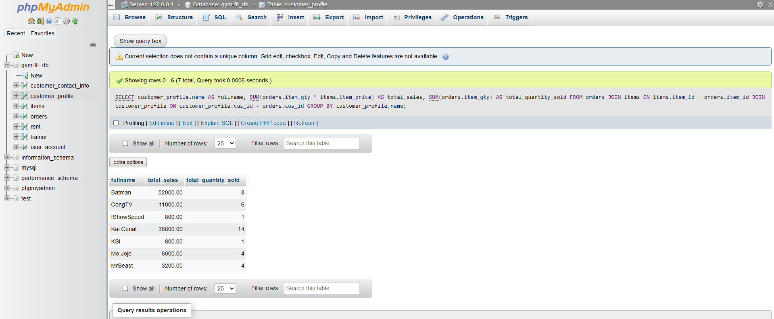



1. **DISPLAYING THE NUMBER OF ITEMS BROUGHT BY CUSTOMERS USING COUNT(*):**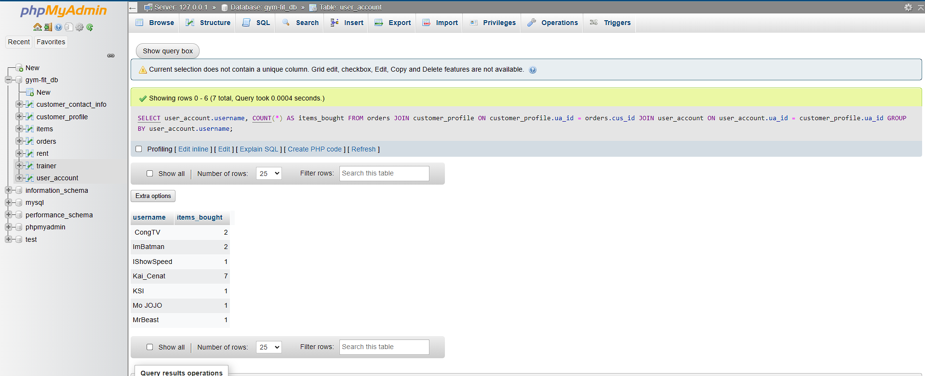



**In this step, we displayed the number of items bought by each username. To achieve this, we used the COUNT(*) function in our SQL query, which allowed us to count the total number of purchases associated with each user. By grouping the results by username, we could easily see how many items each individual had bought, providing valuable insights into user activity and engagement in our application. This analysis helps us understand purchasing patterns and can inform future marketing strategies.**

1. **USING WILDCARDS:**

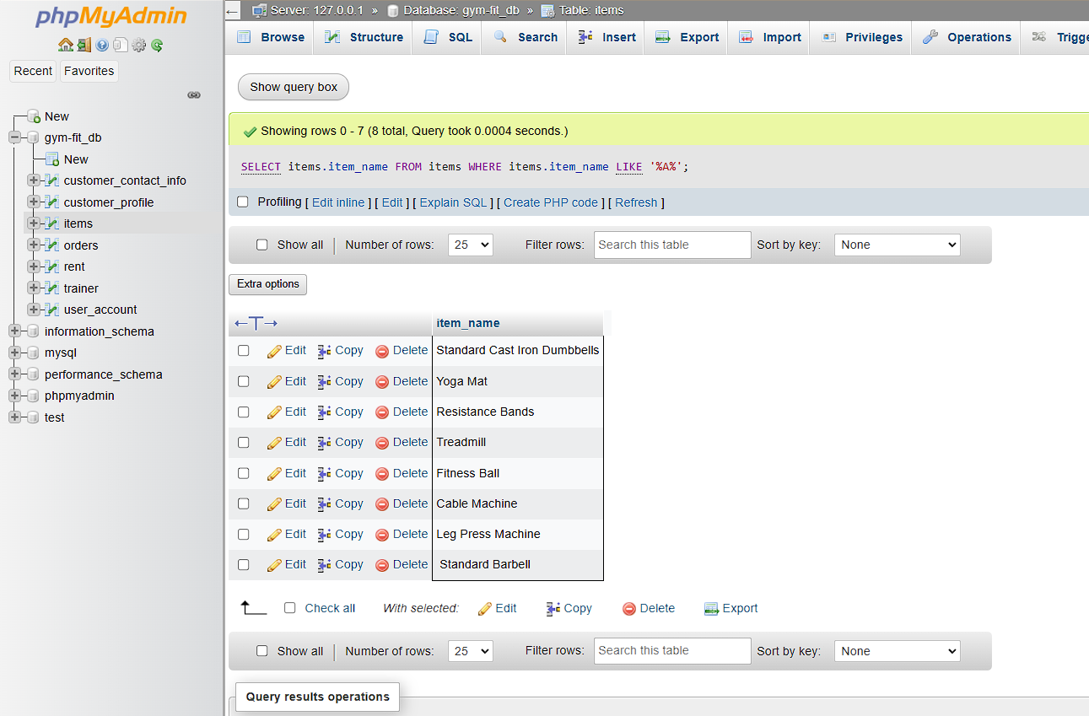



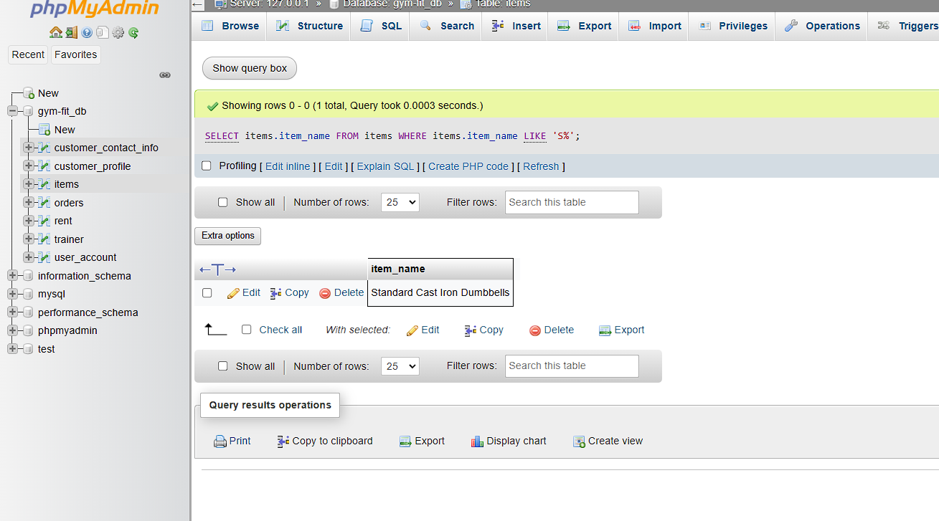

**Here, we used the wildcards to display the items from a particular string starting. We used the SQL LIKE operator along with a wildcard character to filter out our result and make sure only those items were displayed which matched our search criteria. Using this method made it easier and faster for us to pick the relevant items. This is a very useful technique, especially in cases where we would like to highlight specific categories or brands in our inventory.**